DESIGN OF A FASHION RETAIL TREND AND SEASONAL DEMAND VISUALIZATION PLATFORM
A CAPSTONE PROJECT REPORT

Submitted in the partial fulfilment for the Course of

DSA0601- Data Handling and Visualization
to the award of the degree of
BACHELOR OF TECHNOLOGY
IN
AI&DS

Submitted by
A Roja [192424226]

Under the Supervision of

Dr. S Senthilvadivu



SIMATS ENGINEERING
Saveetha Institute of Medical and Technical Sciences Chennai-
602105
SEP 2026



SIMATS ENGINEERING
Saveetha Institute of Medical and Technical Sciences Chennai-602105

BONAFIDE CERTIFICATE
This is to certify that the Capstone Project entitled “Design of a Fashion Retail Trend and Seasonal Demand Visualization Platform” has been carried out by A Roja [192424226] under the supervision of Dr. S Senthilvadivu. and is submitted in partial fulfilment of the requirements for the current semester of the B.Tech [AI&DS] program at Saveetha Institute of Medical and Technical Sciences, Chennai.

Course Coordinator Course Faculty
Title name Dr. S Senthilvadivu
Branch Professor
Department name Department of CSE
Saveetha School of Engineering Saveetha School of Engineering
SIMATS SIMATS



SIMATS ENGINEERING
Saveetha Institute of Medical and Technical Sciences
Chennai-602105

DECLARATION

We, A Roja [192424226] of the Artificial Intelligence and Data Science, SIMATS Engineering, Saveetha Institute of Medical and Technical Sciences, Chennai, hereby declare that the Capstone Project Work entitled “Design of a Fashion Retail Trend and Seasonal Demand Visualization Platform” is the result of our own Bonafide efforts. To the best of our knowledge, the work presented herein is original, accurate, and has been carried out in accordance with the principles of engineering ethics and academic integrity. All sources, references, data, and other materials used in the project have been appropriately acknowledged. We further declare that the data, results, analysis, and findings presented in this report have not been fabricated, falsified, or manipulated. Any external tools, software, datasets, computational resources, or AI-assisted tools used during the project have been appropriately disclosed. We confirm that all applicable ethical, academic, institutional, and professional requirements have been duly followed throughout the planning, execution, analysis, and documentation of the project.

Place: Chennai
Date:

Signature of the Student with Name
A Roja [192324226]

SIMATS ENGINEERING
Saveetha Institute of Medical and Technical Sciences Chennai
602105

Individual Contribution Statement

Student Name / Register No. | Specific Responsibilities | Design & Development Contribution | Testing & Analysis Contribution | Report Contribution | Approx. Contribution (%)
A Roja – 192424226 | Responsible for Module 1: Fashion Sales Data Wrangling & Category Tagging. | Collected and cleaned the dataset using Pandas and categorized products based on category, style, and season. | Checked missing values, duplicates, data consistency, and category accuracy. | Contributed to data collection, preprocessing, Module 1, testing, and documentation. | __%
M Arshini – 192424322 | Responsible for Module 2: Seasonal Demand Distribution & Proportion. | Analyzed seasonal sales and developed Violin Plot and Sunburst Chart visualizations using Plotly. | Tested seasonal results and checked category and style proportions. | Contributed to Module 2, visualization methods, results, and documentation. | __%
Akshaya R – 192524118 | Responsible for Module 3: Trend Forecasting & Style Association. | Developed time-series analysis, Moving Average forecasting, and Bubble Chart for price-popularity analysis. | Tested trend results and analyzed forecasting and price-popularity relationships. | Contributed to Module 3, analysis, results, future scope, and documentation. | __%
Total |  |  |  |  | 100%

ABSTRACT
The fashion retail industry generates a large amount of sales data from different products, categories, styles, seasons, prices, and customer preferences. Understanding this data is important because fashion demand changes according to seasons, styles, and customer preferences. However, raw sales data can be difficult to understand without proper data processing and visualization.
This project focuses on developing a Fashion Retail Trend and Seasonal Demand Visualization Platform to analyze fashion sales data and identify useful patterns. The system uses Pandas for data wrangling, cleaning, organization, and category tagging. Plotly is used to create interactive visualizations for presenting the analyzed data.
The project consists of three main modules. The first module performs fashion sales data wrangling and category tagging based on category, style, and season. The second module analyzes seasonal demand distribution and category-style proportions using Violin Plots and Sunburst Charts. The third module analyzes monthly demand trends using Multiple Time-Series and Moving Average techniques and studies price-popularity relationships using Bubble Charts.
The platform helps identify seasonal demand peaks, popular categories and styles, monthly sales trends, and relationships between price and popularity. Moving Average analysis helps identify the overall demand trend and trend cycles.
Overall, the project demonstrates how data wrangling and visualization techniques can convert raw fashion sales data into meaningful information. The resulting platform can support retailers in understanding customer demand, planning seasonal products, and making better merchandising decisions.

TABLE OF CONTENTS

Sl. No. | Title | Page No.
1 | DECLARATION BY THE CANDIDATE | 3
2 | INDIVIDUAL CONTRIBUTION STATEMENT | 4
3 | ABSTRACT | 5
4 | LIST OF FIGURES | 7
5 | LIST OF TABLES | 7
7 | CHAPTER 1: Introduction | 8
8 | CHAPTER 2: Literature Review | 11
9 | CHAPTER 3: Engineering Design & Trade-offs, Sustainability, Ethics, Safety, Risk & Security | 14
10 | CHAPTER 4: Implementation, Testing & Results, Project Management | 20
11 | CHAPTER 5: Conclusion & Reflection | 26
 | References | 28
 | Appendices | 29

LIST OF FIGURES

Figure No. | Figure Title | Page No.
Figure 4.1 | Fashion Sales Dataset | 22
Figure 4.2 | Seasonal Sales Violin Plot | 22
Figure 4.3 | Category-Style Sunburst Chart | 23
Figure 4.4 | Monthly Sales Time-Series & Moving Average Trend | 23
Figure 4.5 | Price-Popularity Bubble Chart | 23

LIST OF TABLES

Table No | Table name | Page no
2.1 | Literature Review | 11
2.2 | Comparison of Existing Approaches | 12
2.3 | Proposed Contribution | 13
3.1 | Stakeholder / User Requirements | 14
3.2 | Functional Requirements | 14
3.3 | Non-Functional Requirements | 15
3.4 | Project Constraints | 15
3.5 | Design Specifications | 16
3.6 | Evaluation Matrix | 17
3.7 | Trade-Off Analysis | 18
3.8 | Security | 19
3.9 | Risk Register | 19
4.1 | Test Plan & Verification | 21
4.2 | Achievement of Objectives | 24
4.3 | Project Timeline | 25

CHAPTER 1
INTRODUCTION
1.1 Background Information
The fashion retail industry generates a large amount of sales data from different products, categories, styles, seasons, prices, and customer preferences. Understanding this data is important because customer demand changes according to seasons and fashion trends.
Raw sales data is difficult to understand directly. Data wrangling and visualization can help convert this data into meaningful information. By cleaning and organizing the data, important patterns can be identified more easily.
The proposed Fashion Retail Trend and Seasonal Demand Visualization Platform is designed to analyze fashion retail sales data using Pandas and Plotly. Pandas is used for data cleaning, organization, and category tagging, while Plotly is used to create interactive visualizations.
The project uses Violin Plots to analyze seasonal sales distribution, Sunburst Charts to show category-style proportions, Multiple Time-Series to analyze monthly demand, Moving Average techniques to identify demand trends, and Bubble Charts to study price-popularity relationships.
The platform provides a simple way to understand fashion sales patterns and can support retailers in making better merchandising decisions.
1.2 Project Objectives
• To collect and clean fashion retail sales data using Pandas.
• To organize and categorize data based on category, style, and season.
• To analyze seasonal sales distribution using Violin Plots.
• To visualize category and style proportions using Sunburst Charts.
• To analyze monthly fashion sales trends using Multiple Time-Series.
• To apply Moving Average techniques to identify demand trends.
• To analyze price and popularity relationships using Bubble Charts.
• To develop interactive visualizations using Plotly.
• To provide useful insights for fashion retail and merchandising decisions.
1.3 Significance of the Project
The project is significant because fashion retailers need to understand changing customer demand and sales trends.
The platform helps users identify high-demand and low-demand seasons, popular categories, popular styles, monthly demand changes, and price-popularity relationships.
Violin Plots provide information about seasonal sales distribution. Sunburst Charts provide a hierarchical view of categories and styles.
Time-Series graphs help users understand monthly sales trends, while Moving Average analysis helps identify the overall demand pattern.
Bubble Charts help analyze the relationship between price, popularity score, and sales volume.
The information obtained from these visualizations can support product planning, seasonal inventory planning, and merchandising decisions.
1.4 Scope
The project focuses on analyzing fashion retail sales data using data wrangling and visualization techniques.
The system considers parameters such as:
• Category
• Style
• Season
• Sales Volume
• Price
• Popularity Score
• Month
The scope includes data cleaning, category tagging, seasonal demand analysis, category-style proportion analysis, monthly trend analysis, Moving Average analysis, and price-popularity analysis.
The platform can be used by fashion retailers, clothing brands, online fashion platforms, sales analysts, and merchandising teams.
Future improvements can include Machine Learning-based demand prediction, real-time sales data, recommendation systems, and advanced predictive analytics.
1.5 Methodology Overview
The methodology begins with collecting a suitable fashion retail sales dataset.
The dataset is loaded and processed using Pandas. Missing values, duplicate records, incorrect values, and inconsistent category or style names are handled during preprocessing.
The cleaned data is then categorized based on category, style, and season.
The second stage performs seasonal demand analysis using Violin Plots. This helps identify differences in sales distribution between seasons.
A Sunburst Chart is then used to represent category and style proportions.
The third stage analyzes monthly demand using Multiple Time-Series visualizations. Moving Average techniques are applied to identify the overall trend and demand cycles.
Finally, a Bubble Chart is created to analyze the relationship between product price and popularity, while sales volume can be represented using bubble size.
Plotly is used to create interactive visualizations so that users can explore the fashion sales data easily.

CHAPTER 2
LITERATURE REVIEW AND EXISTING SOLUTIONS
2.1 Review Method
The literature review focuses on existing research and technologies related to fashion retail analytics, sales data visualization, seasonal demand analysis, trend forecasting, and customer preference analysis.
Existing approaches using data visualization and statistical techniques were reviewed to understand how sales patterns, product categories, seasonal demand, and customer preferences can be analyzed.
2.2 Review of Existing Work
S.No. | Existing Work / Technology | Method Used | Major Contribution | Limitation
1 | Traditional Sales Analysis | Tables and basic calculations | Provides basic sales information | Difficult to identify complex patterns
2 | Statistical Sales Analysis | Statistical measures | Helps understand sales performance | Less visual and interactive
3 | Data Visualization | Charts and graphs | Makes sales patterns easier to understand | Depends on selected visualization
4 | Time-Series Analysis | Monthly/seasonal analysis | Identifies demand trends | Historical data is required
5 | Forecasting Techniques | Moving Average | Helps identify overall demand trends | Simple forecasting approach
6 | Interactive Visualization | Plotly-based charts | Allows users to explore data interactively | Requires proper data preparation

2.3 Comparative Analysis
Existing Approach | Advantages | Limitations | Relevance to Proposed Work
Traditional Analysis | Simple | Difficult to identify patterns | Used as basic comparison
Tables | Easy to create | Limited visual understanding | Data presentation
Basic Charts | Easy to understand | May show limited relationships | Used for comparison
Time-Series | Shows changes over time | Requires time-based data | Used for demand trends
Moving Average | Smooths fluctuations | Simple forecasting method | Used for trend analysis
Proposed Platform | Combines multiple visualizations | Requires proper data preparation | Provides integrated fashion retail analysis
2.4 Research / Engineering Gap
• Existing sales analysis methods may focus on only one type of information.
• Raw fashion sales data is difficult to understand directly.
• Seasonal demand patterns may not be clearly visible in tables.
• Category and style proportions require suitable hierarchical visualization.
• Monthly demand trends require time-based visualization.
• Price and popularity relationships require multi-variable visualization.
• Therefore, an integrated platform combining data wrangling, seasonal analysis, trend analysis, and interactive visualization is proposed.

2.5 Proposed Contribution
S.No. | Proposed Contribution | Purpose
1 | Data Wrangling | Clean and organize sales data
2 | Category Tagging | Categorize products based on category, style, and season
3 | Seasonal Analysis | Analyze demand across seasons
4 | Violin Plot | Show seasonal sales distribution
5 | Sunburst Chart | Show category-style proportions
6 | Time-Series Analysis | Analyze monthly demand
7 | Moving Average | Identify overall demand trends
8 | Bubble Chart | Analyze price-popularity relationship
9 | Interactive Platform | Present results using Plotly

CHAPTER 3
ENGINEERING DESIGN, TRADE-OFFS, SUSTAINABILITY, ETHICS, SAFETY, RISK & SECURITY
3.1 Requirements
3.1.1 Stakeholder / User Requirements
Stakeholder | Requirement
Retail Managers | Understand sales and demand patterns
Merchandising Teams | Identify popular products and styles
Sales Analysts | Analyze sales trends
Inventory Managers | Understand seasonal demand
Business Users | View information through simple visualizations
3.1.2 Functional Requirements
S.No. | Functional Requirement
FR1 | The system shall accept fashion sales data as input.
FR2 | The system shall clean and preprocess the dataset.
FR3 | The system shall categorize products based on category, style, and season.
FR4 | The system shall analyze seasonal sales distribution.
FR5 | The system shall display category-style proportions.
FR6 | The system shall analyze monthly sales trends.
FR7 | The system shall calculate Moving Average trends.
FR8 | The system shall analyze price-popularity relationships.
FR9 | The system shall display interactive visualizations.
3.1.3 Non-Functional Requirements
Requirement | Description
Performance | Visualizations should load within reasonable time
Accuracy | Data calculations should be correct
Usability | Visualizations should be easy to understand
Reliability | System should process valid datasets consistently
Scalability | Platform should support larger datasets
Maintainability | Code should be organized and easy to update
3.2 Constraints and Applicable Standards
3.2.1 Project Constraints
Constraint | Effect on Project
Dataset Quality | Missing or incorrect values can affect results
Dataset Size | Large datasets may require more processing
Data Availability | Required parameters must be available
Visualization Complexity | Complex charts may require careful design
Computing Resources | Processing speed depends on system resources
The project should only claim standards that are actually applicable and used during implementation.
3.3 Design Specifications
Parameter | Target / Requirement | Unit | Priority
Input | Fashion sales dataset | Dataset | High
Data Processing | Pandas | — | High
Visualization | Plotly | — | High
Seasonal Analysis | Violin Plot | — | High
Category Analysis | Sunburst Chart | — | High
Trend Analysis | Time-Series | Month | High
Forecasting | Moving Average | — | Medium
Relationship Analysis | Bubble Chart | — | High
3.4 Alternative Solutions and Evaluation
Alternative 1: Basic Spreadsheet Analysis
Advantage: Easy to use and understand.
Disadvantage: Limited interactive visualization and advanced analysis.
Alternative 2: Power BI
Advantage: Provides interactive dashboards and business intelligence features.
Disadvantage: The specified project techniques such as Sunburst and Violin Plot may require additional implementation or custom visuals.
Alternative 3: Python Pandas + Plotly
Advantage: Supports the required data processing and specified visualization techniques.
Disadvantage: Requires Python programming knowledge.
Selected Approach
Pandas + Plotly is selected because it directly supports the project requirements and allows implementation of Violin Plots, Sunburst Charts, Time-Series, Moving Average, and Bubble Charts.
Evaluation Matrix
Criterion | Weight | Spreadsheet | Power BI | Pandas + Plotly
Data Processing | 20% | 3 | 4 | 5
Visualization | 25% | 3 | 5 | 5
Required Charts | 20% | 2 | 3 | 5
Interactivity | 15% | 2 | 5 | 4
Flexibility | 10% | 3 | 4 | 5
Implementation Suitability | 10% | 3 | 4 | 5
Overall Suitability | 100% | — | — | High
These are design-evaluation scores and not experimental performance measurements.
3.5 Selected Design and Detailed Design
System Architecture
Fashion Sales Dataset
↓
Data Cleaning & Wrangling
↓
Category & Style Tagging
↓
Seasonal Demand Analysis
↓
Category-Style Proportion Analysis
↓
Monthly Time-Series Analysis
↓
Moving Average Analysis
↓
Price-Popularity Analysis
↓
Interactive Plotly Visualizations
↓
Retail / Merchandising Insights
3.6 Trade-Off Analysis
Design Decision | Alternative | Benefit | Disadvantage | Final Decision
Data Processing | Spreadsheet | Simple | Limited automation | Pandas selected
Visualization | Basic Charts | Easy | Less detailed | Plotly selected
Trend Analysis | Raw Sales | Simple | Fluctuations remain | Moving Average selected
Category Analysis | Bar Chart | Easy | Hierarchy not clear | Sunburst selected
Seasonal Analysis | Box Plot | Simple | Less distribution detail | Violin Plot selected
Relationship Analysis | Scatter Plot | Simple | Limited visual dimension | Bubble Chart selected
3.7 Sustainability, Ethics, Safety, Risk & Security
3.7.1 Sustainability
• The project is mainly software-based and does not require additional physical infrastructure.
• Existing computing resources can be used for development.
• Efficient data processing can reduce unnecessary computational usage.
• The platform can support better inventory planning by helping retailers understand demand patterns.
3.7.2 Ethics
Fashion sales data should be used responsibly.
If the dataset contains customer-related information, privacy should be maintained.
Only necessary information should be used for analysis.
Data should not be manipulated to produce misleading results.
3.7.3 Security
Security Consideration | Possible Risk | Mitigation
Dataset | Unauthorized access | Restrict access to data
System Access | Unauthorized usage | Use appropriate access controls
Results | Modification of results | Protect generated files
Software | Outdated packages | Keep dependencies updated
3.7.4 Risk Register
Risk | Likelihood | Severity | Risk Level | Mitigation
Missing Data | Medium | Medium | Medium | Handle missing values
Duplicate Data | Medium | Low | Medium | Remove duplicates
Incorrect Categories | Medium | Medium | Medium | Standardize categories
Poor Dataset Quality | Medium | High | High | Validate dataset
Large Dataset | Medium | Medium | Medium | Optimize processing
Incorrect Visualization | Low | Medium | Low | Verify calculations
System Error | Low | Medium | Low | Test code before execution

CHAPTER 4
IMPLEMENTATION, TESTING & RESULTS
4.1 Development Approach & Resources
The project is developed using a modular approach.
The fashion sales dataset is first processed using Pandas. The cleaned data is then analyzed using different visualization techniques.
Plotly is used to create interactive visualizations.
The implementation consists of three major modules:
Module 1: Fashion Sales Data Wrangling & Category Tagging
Module 2: Seasonal Demand Distribution & Proportion
Module 3: Trend Forecasting & Style Association
4.2 Implementation
Module 1: Fashion Sales Data Wrangling & Category Tagging
The fashion sales dataset is collected as the primary input for the project and loaded into Python using the Pandas library. The dataset is examined to understand its structure, columns, data types, and sales-related information. Basic data validation is performed to ensure that the data is suitable for further processing and analysis.
The data is cleaned by checking for missing values, duplicate records, incorrect entries, and inconsistent formats. Missing or invalid values are handled appropriately, and duplicate records are removed to improve data quality. Numerical and categorical fields are also standardized so that the dataset remains consistent and reliable.
After cleaning, the products are organized into meaningful categories based on product category, style, and season. These tags help in identifying sales patterns and comparing different fashion segments. The final cleaned and categorized dataset is then prepared for data analysis, visualization, and dashboard development in the subsequent modules.
Module 2: Seasonal Demand Distribution & Proportion
• Sales are grouped according to season.
• Seasonal sales distribution is analyzed.
• Violin Plot is created to compare seasonal sales.
• Category and style information is grouped hierarchically.
• Sunburst Chart is created to display category-style proportions.
Module 3: Trend Forecasting & Style Association
• Monthly sales data is analyzed.
• Multiple Time-Series graphs are created.
• Moving Average is calculated to smooth sales fluctuations.
• Overall demand trends are identified.
• Price and popularity are analyzed.
• Bubble Chart is created using price, popularity, and sales volume.
4.3 Test Plan & Verification
Requirement | Test Method | Acceptance Criterion | Status
Dataset Input | Load dataset | Dataset loads successfully | To Test
Data Cleaning | Check missing/duplicate values | Clean dataset generated | To Test
Category Tagging | Check categories | Categories correctly assigned | To Test
Violin Plot | Generate seasonal plot | Seasonal distribution displayed | To Test
Sunburst Chart | Generate chart | Category-style hierarchy displayed | To Test
Time-Series | Generate monthly graph | Monthly trends displayed | To Test
Moving Average | Calculate average | Trend line displayed | To Test
Bubble Chart | Generate chart | Price-popularity relationship displayed | To Test
Interactive Output | Test Plotly controls | Visualization responds correctly | To Test
4.4 Results
Figure 4.1 – Fashion Sales Dataset
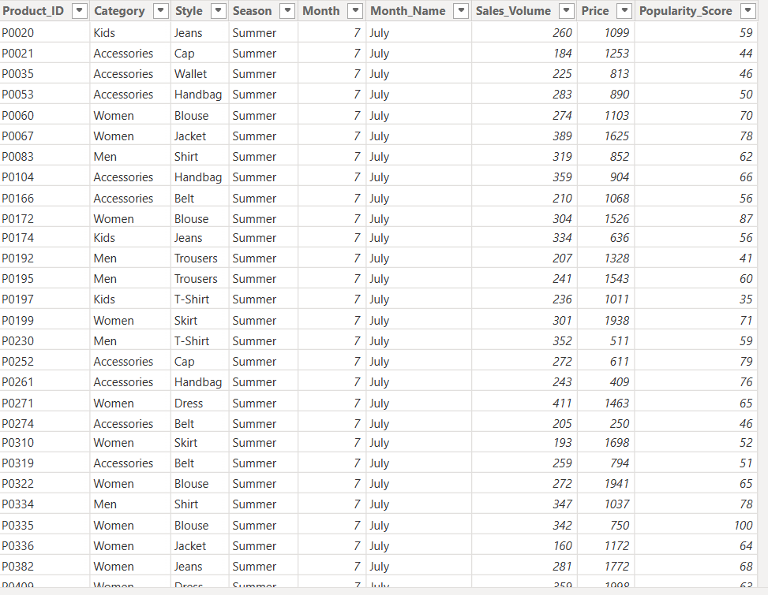
Figure 4.2 – Seasonal Sales Violin Plot
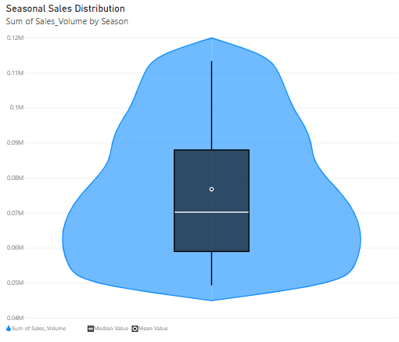

Figure 4.3 – Category-Style Sunburst Chart
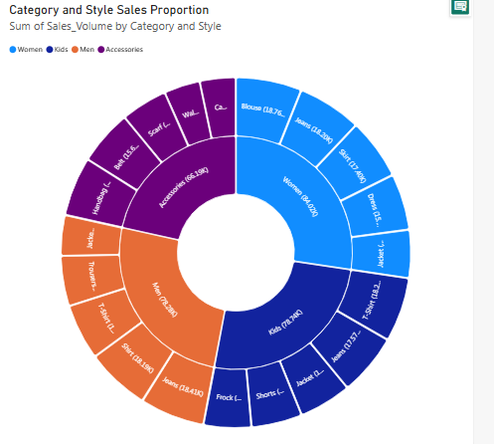
Figure 4.4 – Monthly Sales Time-Series & Moving Average Trend
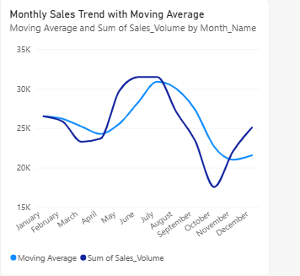
Figure 4.5 – Price-Popularity Bubble Chart
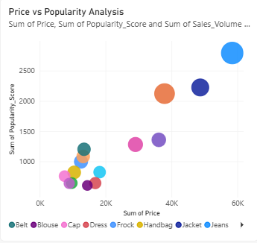

4.5 Data Analysis & Engineering Judgment
The platform is evaluated based on the quality of data processing and the clarity of the generated visualizations.
The Violin Plot is used to understand seasonal sales distribution. The Sunburst Chart provides a hierarchical representation of categories and styles.
The Time-Series visualization is used to identify monthly demand patterns, while Moving Average analysis helps reduce short-term fluctuations and identify the overall trend.
The Bubble Chart helps analyze price, popularity, and sales volume together.
The final visualizations are interpreted based on the actual dataset and results obtained during implementation.
4.6 Achievement of Objectives
Objective | Evidence | Achievement
Clean sales data | Processed dataset | To be evaluated
Categorize products | Category/style/season fields | To be evaluated
Analyze seasonal demand | Violin Plot | To be evaluated
Analyze category-style proportion | Sunburst Chart | To be evaluated
Analyze monthly trends | Time-Series | To be evaluated
Identify demand trends | Moving Average | To be evaluated
Analyze price-popularity | Bubble Chart | To be evaluated
Create interactive platform | Plotly output | To be evaluated
4.7 Strengths & Limitations
Strengths
• Easy-to-understand visualizations.
• Interactive Plotly-based platform.
• Multiple visualization techniques are integrated.
• Helps identify seasonal demand patterns.
• Supports category and style analysis.
• Shows monthly demand trends.
• Helps analyze price and popularity relationships.
Limitations
• Results depend on the quality of the dataset.
• Moving Average provides a simple trend estimation.
• Missing data may affect analysis.
• The platform depends on the available sales parameters.
• It does not currently use advanced Machine Learning forecasting.
4.8 Project Planning
Phase | Activity
1 | Literature Review
2 | Dataset Collection
3 | Data Cleaning
4 | Category Tagging
5 | Seasonal Visualization
6 | Sunburst Visualization
7 | Time-Series Analysis
8 | Moving Average
9 | Bubble Chart
10 | Testing
11 | Results

CHAPTER 5
CONCLUSION, FUTURE WORK AND REFLECTION
5.1 Conclusion
The Fashion Retail Trend and Seasonal Demand Visualization Platform was developed to analyze fashion sales data using data wrangling and visualization techniques.
The project combines Pandas and Plotly to process and visualize fashion retail information.
The three modules perform data wrangling and category tagging, seasonal demand and proportion analysis, and trend forecasting with price-popularity analysis.
Violin Plots are used for seasonal sales distribution, Sunburst Charts are used for category-style proportions, Time-Series graphs are used for monthly demand trends, Moving Average is used to identify overall trends, and Bubble Charts are used to analyze price and popularity relationships.
Overall, the project demonstrates how data visualization can convert raw fashion sales data into meaningful information and support better merchandising decisions.
5.2 Future Work
• Implement Machine Learning-based demand forecasting.
• Integrate real-time fashion sales data.
• Add personalized fashion recommendations.
• Include advanced predictive analytics.
• Add inventory-level analysis.
• Develop a web-based version of the platform.
• Integrate the system with e-commerce platforms.
5.3 Professional Learning & Individual Reflection
New Knowledge Acquired
• Learned practical data wrangling using Pandas.
• Learned how to clean and organize sales datasets.
• Learned different visualization techniques using Plotly.
• Understood Violin Plots and Sunburst Charts.
• Learned Time-Series and Moving Average analysis.
• Learned how to create Bubble Charts.
• Learned how to interpret visualization results.
Engineering & Professional Skills Developed
• Python programming
• Pandas data processing
• Plotly visualization
• Data analysis
• Problem-solving
• Testing and debugging
• Data interpretation
• Technical documentation
• Presentation skills
Individual Reflection – A Roja
The main challenge I encountered was understanding how to clean and organize the fashion sales data before creating the visualizations. I solved this by learning Pandas data-processing techniques and checking the dataset step by step.
I worked on data wrangling, category tagging, seasonal analysis, trend analysis, and visualization development. Through this project, I gained practical knowledge of Pandas and Plotly and learned how different visualization techniques can be selected according to the type of data.
I also learned how to interpret visual results and convert them into useful retail insights. This project improved my Python programming, data analysis, visualization, testing, and problem-solving skills.
REFERENCES
- Sharma, M., Sharma, N., & Verma, P. (2026, January). Visualizing Trends and Correlation Between Fashion Features for Product Design Prediction Using Classification and Sentiment Analysis. In Computer Sciences & Mathematics Forum (Vol. 12, No. 1, p. 16). MDPI.
- Mahto, R. R., & Rodriguez, C. Q. (2025, January). AI Integration in Fashion Trend Forecasting and Garment Design Development. In International Conference on Functional Textiles and Clothing (pp. 227-240). Singapore: Springer Nature Singapore.
- Ledesma Gonzalez, C. A. (2026). The Influence of Weather on Fashion Retail: Developing a Sustainable and Interpretable Forecasting Model (Doctoral dissertation, Dublin, National College of Ireland).
- Luo, J., & Khunsiri, W. (2026). The Critical Role of AI and Big Data in Revolutionizing Apparel Design. International Journal of Sociologies and Anthropologies Science Reviews, 6(5), 163-174.
- Yogesh, L., Ritik, B., Prajesh, K., Ayush, S., & Suman Sen, G. (2024). Urban-Clothing Custom Clothing Website. International Journal of Trend in Scientific Research and Development, 8(5), 785-793.
- Ledesma Gonzalez, C. A. (2026). The Influence of Weather on Fashion Retail: Developing a Sustainable and Interpretable Forecasting Model (Doctoral dissertation, Dublin, National College of Ireland).
- Emma, L. (2025). Sustainability-Focused Color Variation Management Using AI: A Circular Economy Perspective.
- Kim, I. (2025). Fashion trends. Publifye AS.
- Alanadoly, A. B., Sidhu, S. K., & Richards-Carpenter, N. (2024). AI landscape in fashion: Insights on transforming design, supply chains, marketing, and consumer experiences. In Illustrating digital innovations towards intelligent fashion: Leveraging information system engineering and digital twins for efficient design of next-generation fashion (pp. 417-439). Cham: Springer Nature Switzerland.
- Sayedelahl, A. A. (2025). Online markets as a Tool for Rug Design Future Trend Forecasting Using Linear Regression. International Design Journal, 15(6), 535-544.

APPENDICES
Appendix A – Implementation
The project was developed using Microsoft Power BI and Power Query. The main implementation activities included:
- Dataset import and loading
- Data cleaning and transformation
- Missing-value and duplicate handling
- Category, style, and season classification
- Creation of required visualizations
- Time-series and moving-average analysis
- Interactive dashboard development using filters and slicers
Appendix B – Dataset Details
Parameter | Details
Input Type | Fashion Retail Sales Dataset
File Format | CSV
Data Processing | Power Query
Visualization Tool | Power BI
Category | Fashion product category
Style | Product style
Season | Spring / Summer / Autumn / Winter
Sales Volume | Number of products sold
Price | Product price
Popularity Score | Product popularity
Month | Month of sale

Appendix C – Output
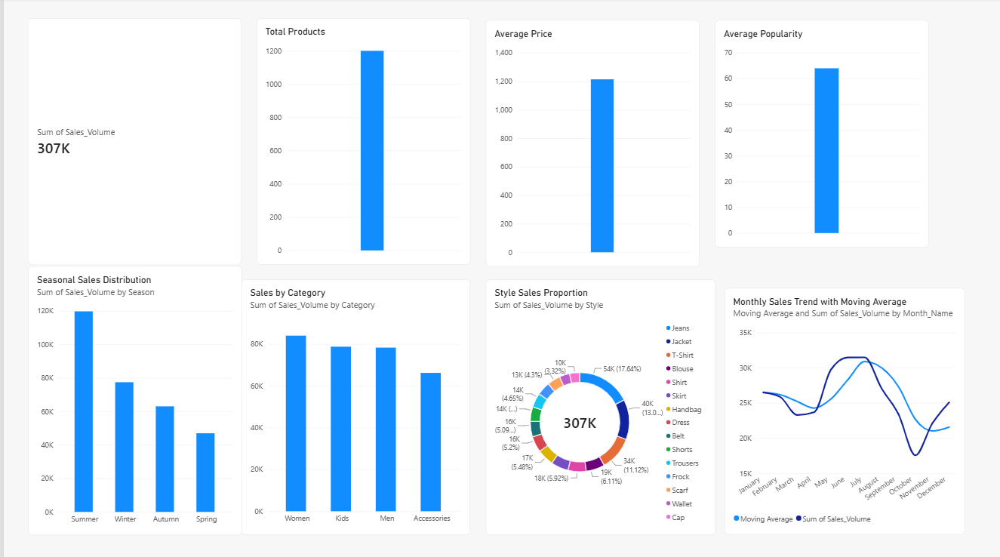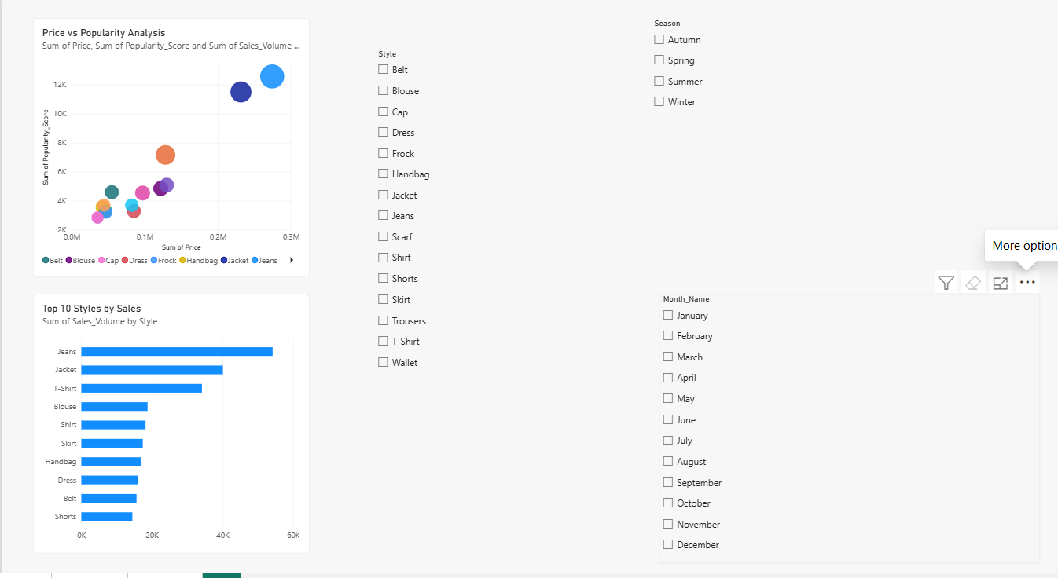
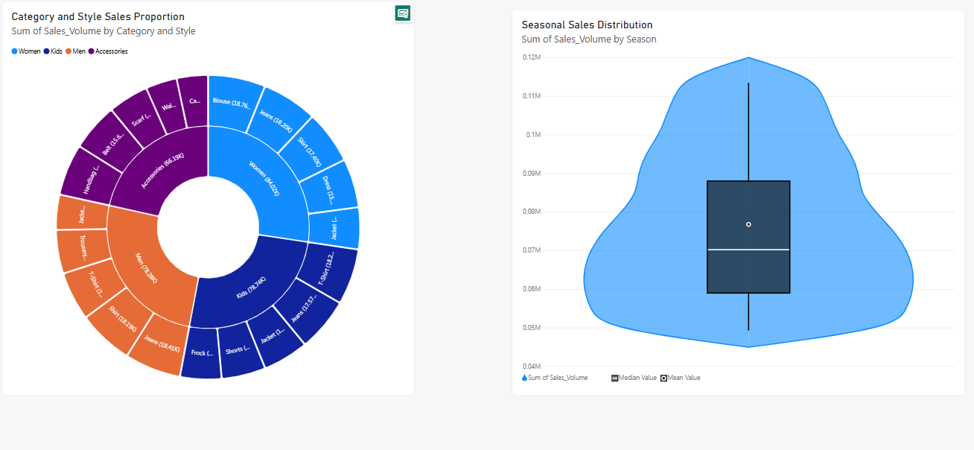
Appendix D – Test Results
Test Case | Actual Result | Status
Dataset Loading | Dataset loaded successfully | Pass
Data Cleaning | Data cleaned using Power Query | Pass
Category Tagging | Categories assigned successfully | Pass
Visualizations | Required charts displayed correctly | Pass
Dashboard | Interactive dashboard worked successfully | Pass

Appendix E – Performance Results
Parameter | Result
Dataset Records | Actual dataset records
Categories | Actual number of categories
Seasons | Actual number of seasons
Visualization Types | 5
Processing Tool | Power Query
Visualization Tool | Power BI
Trend Analysis | Moving Average

Appendix F – Software and Hardware Requirements
Software Requirements
- Microsoft Power BI Desktop
- Power Query
- Microsoft Windows
- Web Browser
Hardware Requirements
- Processor: Intel Core i3 or above
- RAM: 4 GB minimum, 8 GB recommended
- Storage: 10 GB available space
- System: Standard laptop/desktop
- Internet: Required for dataset collection when needed

